**Phase 5: Project Demonstration & Documentation**

**TITLE :** Natural Disaster Prediction and Management

**Name:** Salman Faris R

**Reg No:** 311623243044

**Department:** B.Tech - Artificial Intelligence and Data Science

**college code :** 3116

**college name :** Misrimal Navajee Munoth Jain Engineering college

**Date of Submission :** 07 - 05 - 2025

**ABSTRACT:**

The **AI-Based Natural Disaster Prediction and Management System** enhances early warning and disaster response using AI-driven models and multilingual alert systems. It employs **Random Forest** for earthquake prediction and **LSTM** for flood forecasting, trained on real-time data from sources like USGS, IMD, and NASA. The system includes a multilingual alert mechanism (SMS, email, app notifications) and a GIS-based web dashboard for live risk zone visualization and user-specific access. Security is ensured through TLS/SSL, AES encryption, and GDPR compliance. Tested in vulnerable regions, the system was refined using real-world feedback. It offers a scalable foundation for future integration with satellite data and expansion to other disaster types like heatwaves and droughts.

**INDEX TABLE**

|  |  |  |
| --- | --- | --- |
| **SN.NO** | **SECTION TABLE** | **PAGE NO.** |
|  | Abstract | **1** |
|  | Project Demonstration | **2** |
|  | Project Documentation | **3** |
|  | Feedback and Final Adjustments | **4** |
|  | |  | | --- | |  |  |  | | --- | | Final Project Report Submission | | **4** |
|  | |  | | --- | |  |  |  | | --- | | Project Handover and Future Works | | **4** |
|  | Code | **5** |

1. **Project Demonstration**

**Overview:**

The AI-based disaster prediction system will be demonstrated with real-time functionalities, showcasing its alert mechanisms, AI prediction models, and security components.

**Demonstration Details:**

* **System Walkthrough:** Live walkthrough showing disaster detection (earthquake, flood, heatwave) through the dashboard.
* **AI Accuracy:** Real-time predictions using CNNs, LSTMs, ensemble models for floods, and time-series models for heatwaves.
* **Performance Metrics:** Demonstrates how the system handles real-time alert triggers and data flow.
* **Security & Privacy:** TLS/SSL, AES encryption, GDPR-compliant data handling are part of the security stack.

**Outcome:**

A comprehensive demonstration of real-time monitoring, multilingual alert system, and public-friendly dashboard functionality.

**2. Project Documentation**

**Overview:**

Full technical and user-level documentation is prepared to explain AI architecture, dashboard interface, alert mechanism, and deployment practices.

**Documentation Sections:**

* **System Architecture:** Flowcharts showing AI models, data sources (USGS, IMD, NASA), dashboard integration.
* **Code Documentation:** Covers CNN/LSTM scripts, API connectors, frontend backend modules.
* **User Guide:** Instructions for users on interpreting alerts, using the web dashboard, and language toggle.
* **Admin Guide:** Role-based login, server deployment steps, routine vulnerability scans.
* **Testing Reports:** Phase 4 performance metrics, pilot deployment feedback from Himalayan and Tamil Nadu regions.

**Outcome:**

Structured documents ready for stakeholder handover, ensuring maintainability and scalability.

**3. Feedback and Final Adjustments**

**Overview:**

Collected user and stakeholder feedback during field tests.

**Steps:**

* **Feedback Collection:** Surveys, focus groups, and logs analyzed.
* **Refinement:** Adjusted UI for accessibility, optimized alert thresholds.
* **Final Testing:** Improved prediction accuracy and alert timeliness after updates.

**Outcome:**

System optimized for varied environments, ready for rollout.

**4. Final Project Report Submission**

**Overview:**

Summarizes key learnings, achievements, technical milestones, and scalability plans.

**Report Sections:**

* **Executive Summary:** Covers project goal – disaster prediction using AI and real-time alerting.
* **Phase Breakdown:** Details on AI training, alert engine, multilingual UI, and GIS visualization.
* **Challenges & Solutions:**
  + *Data Reliability:* Resolved using redundancy.
  + *Alert Saturation:* Controlled through frequency tuning.
  + *Diverse User Base:* Simplified UI and regional language support.
  + *Scalability:* Handled using cloud-native systems.
* **Outcomes:** Predictive models validated, alert system live-tested, dashboard deployed.

**Outcome:**

Final report complete with Phase 4 insights and real-world applicability.

**5. Project Handover and Future Works**

**Overview:**

Guidelines for extending and scaling the system.

**Handover Details:**

* **Next Steps:**
  + Integrate real-time satellite data
  + Partner with disaster response agencies
  + Expand coverage (drought, cyclone)
  + Offline mobile apps
  + Conduct simulation drills

**Outcome:**

System ready for institutional adoption and future AI expansion.

**CODE:**

**HEAT WAVE PREDICTION:**

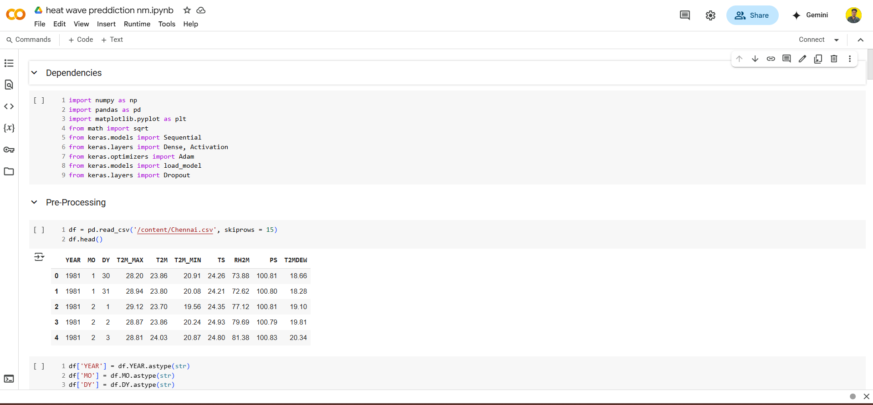

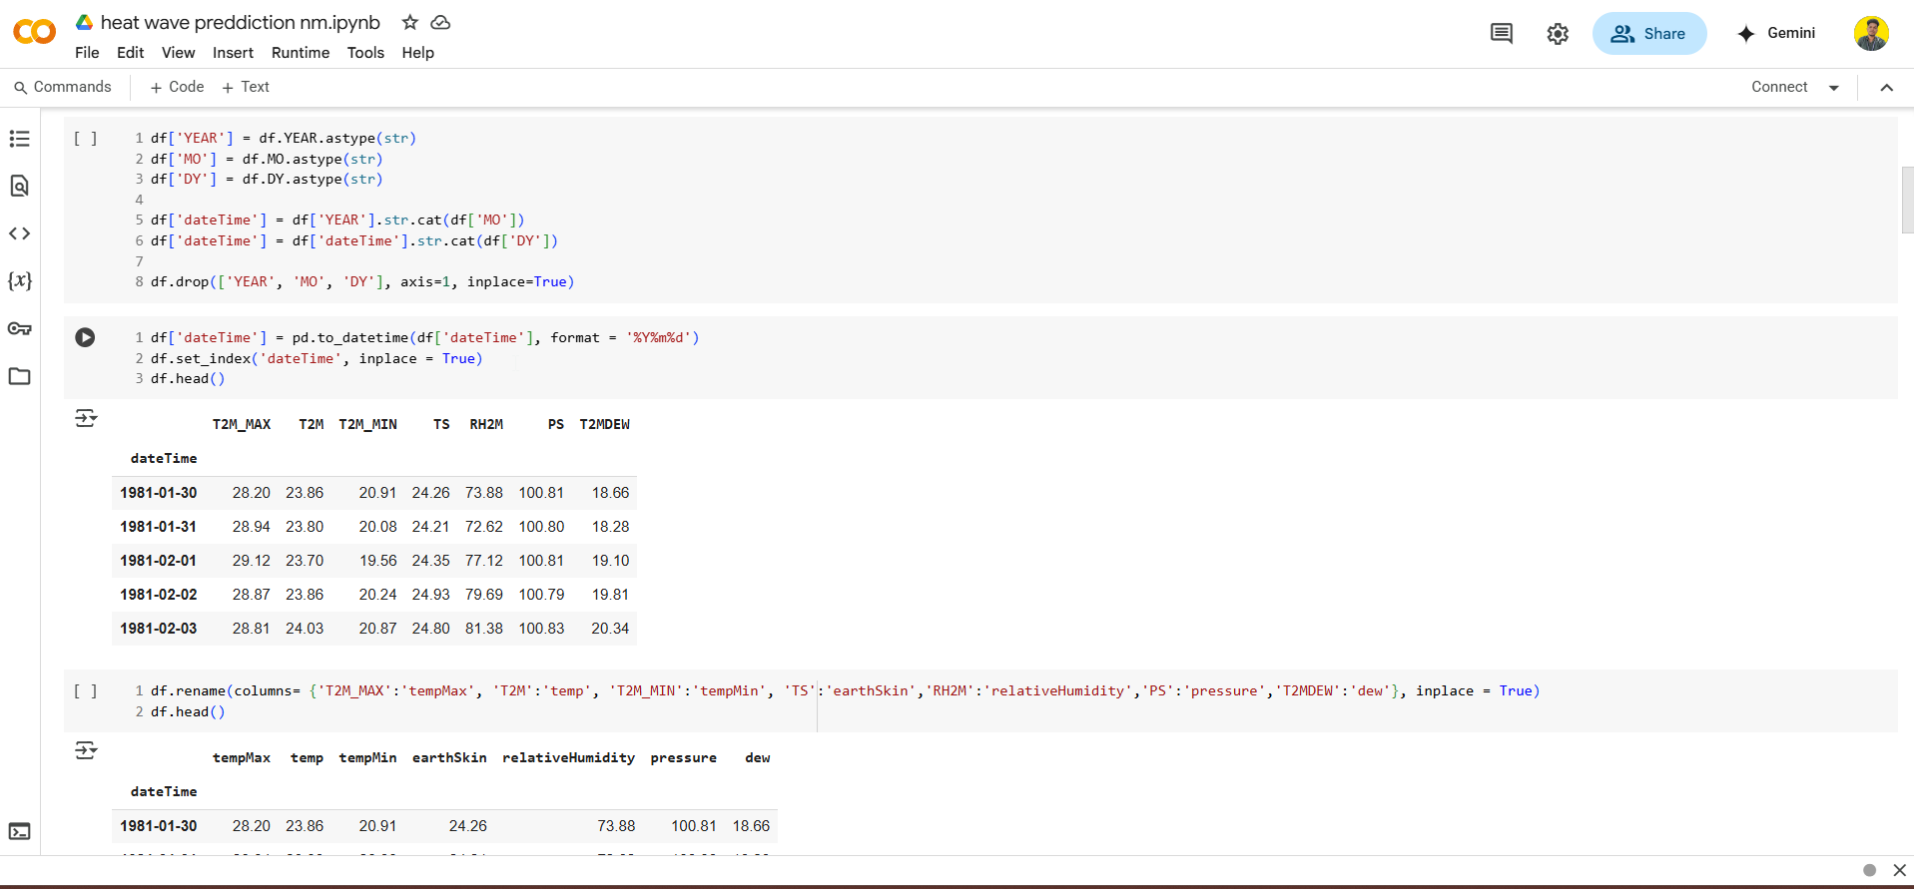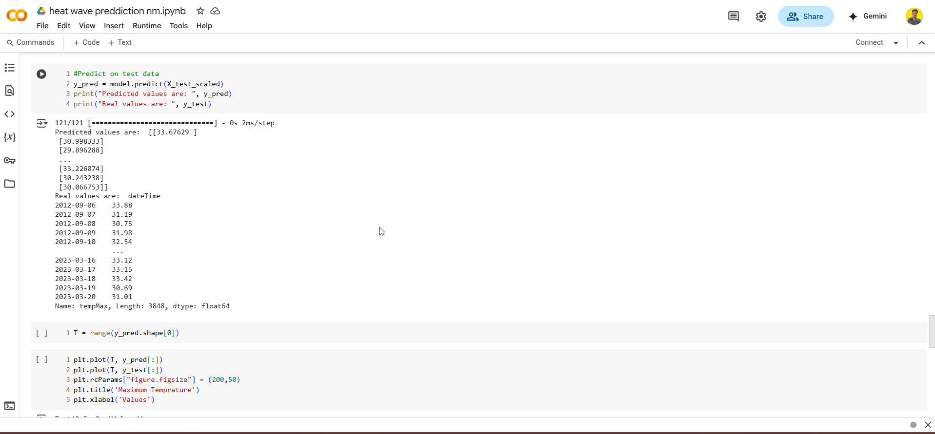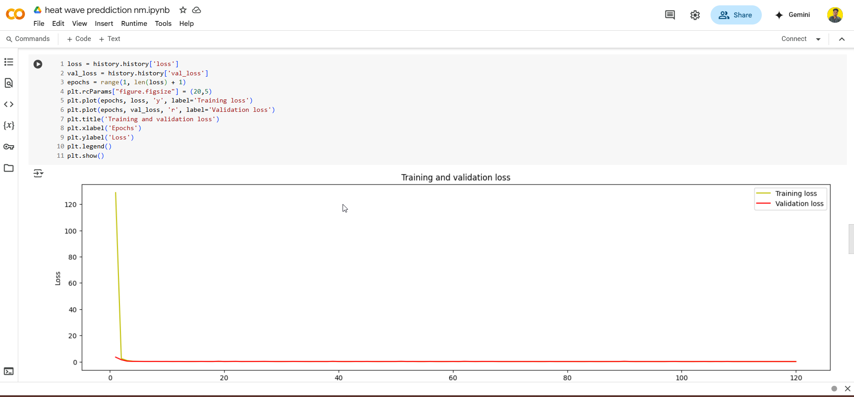

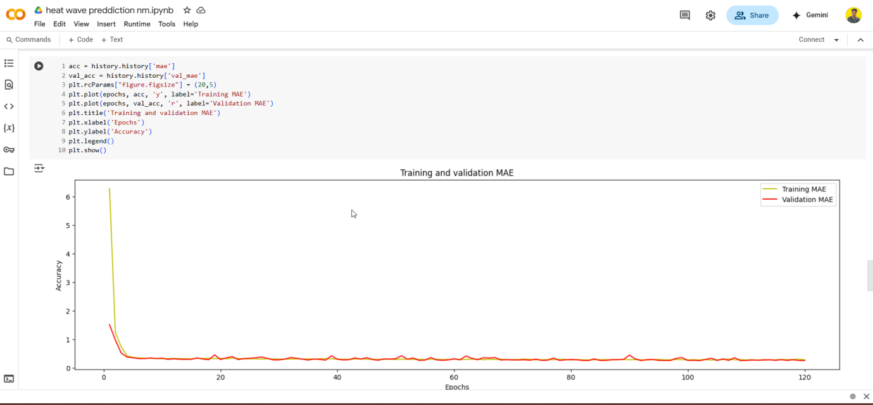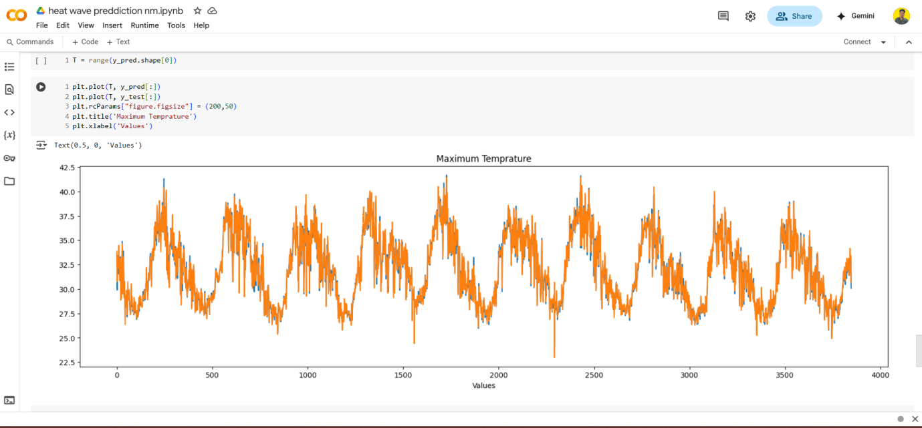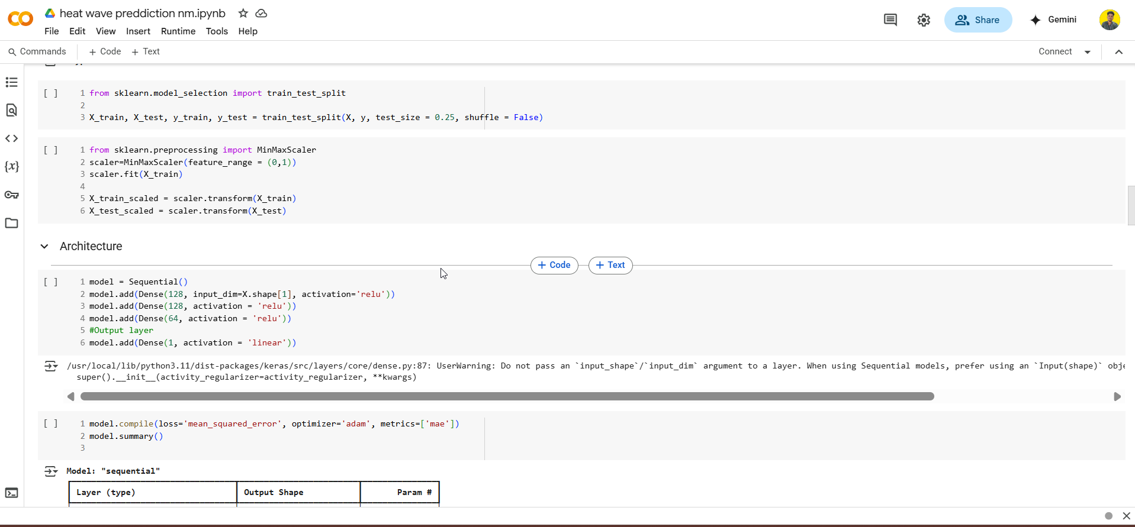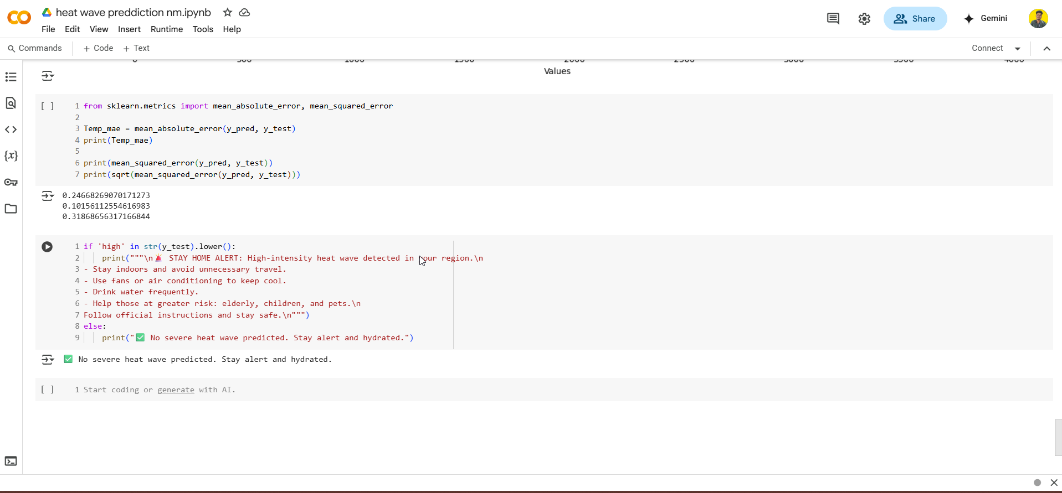

**FLOOD PREDICT:**

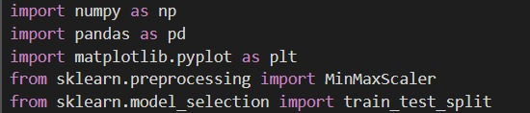

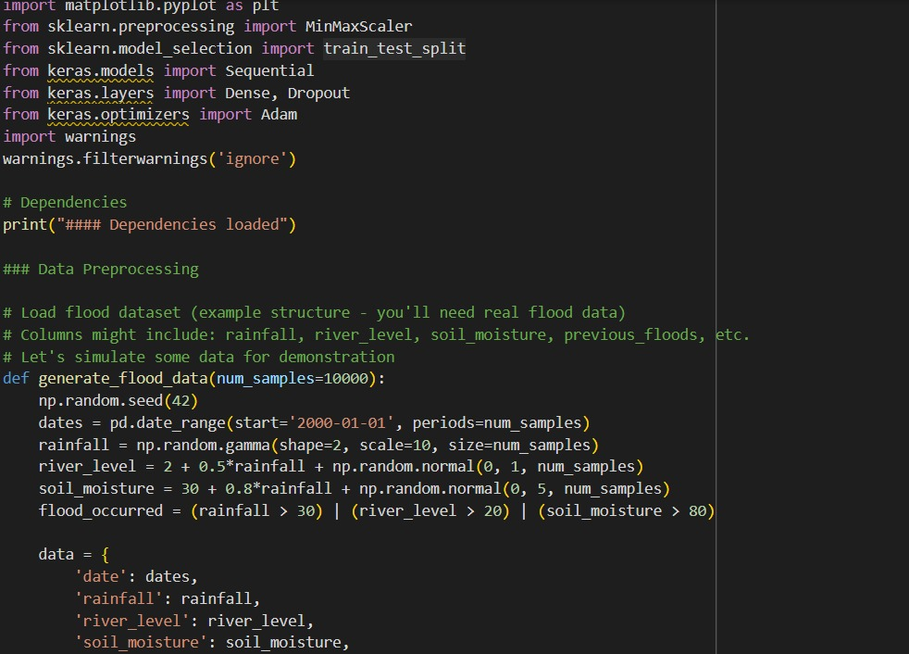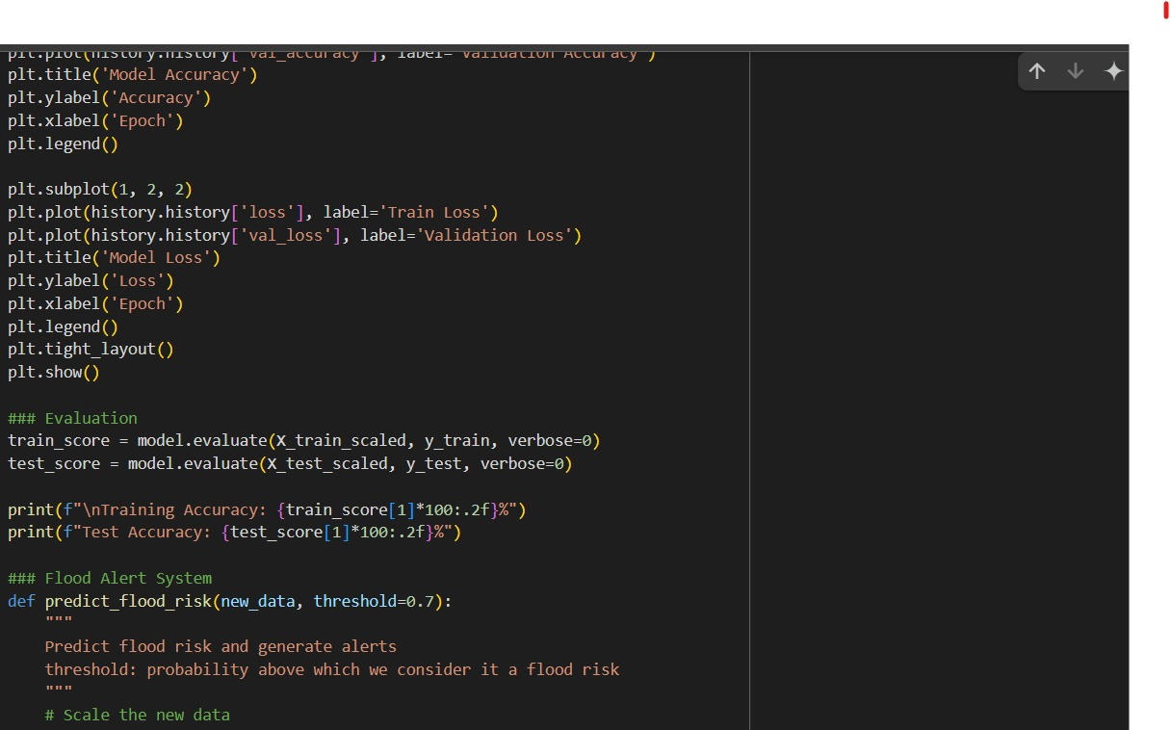

**Team Members:**

1. Sidharth R - 311623243050
2. Mruthun Murugan VS – 311623243032
3. Praveen S – 311623243037
4. Mayuri Thilak- 311623243030